**Experiment No. 1.8**

**Student Name:** Gaurav Kumar **UID:** 22MCC20177

**Branch:** MCA**–**CCD **Section/Group:** MCD-1/A

**Semester:** III **Date of Performance:** 25th Oct 23

**Subject Name:** Business Analytics **Subject Code:** 22CAH-703

1. **Aim/Overview of the practical:**
   1. Write the steps to install Tableau.
2. **Code for practical: (a)**

**Tableau:** Tableau is a data visualization tool that businesses use to analyze data.

It allows users to create interactive dashboards that depict trends, variations, and

density of data in the form of graphs and charts. Tableau is used by businesses of

all sizes for

* Quickly and easily analyze data.
* Share insights with stakeholders.
* Explore data with limitless visual analytics.

1. Search for Tableau in google and Select Tableau for students.
2. Register for a student account and verify the e-mail address and get a Product Key for Tableau.

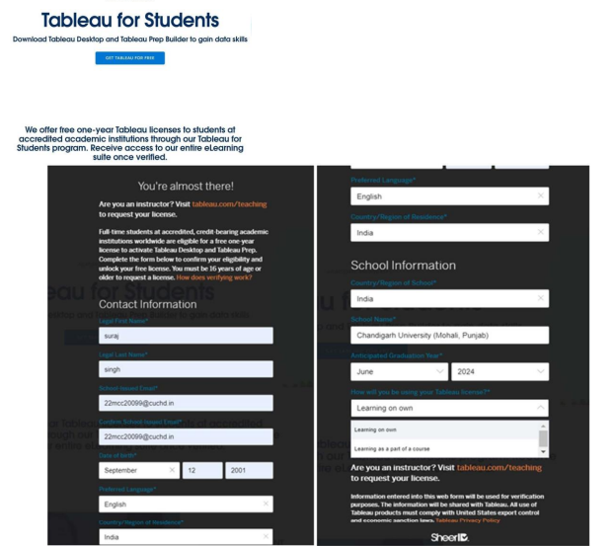

1. Download Tableau software and start installing.

1. Once the installation is complete enter the product key and enter the required details to complete registration.

1. Once the registration is complete you can see the Tableau UI.

